
CS 111 – Programming Fundamentals
Lab # 07
Array Tasks

––
Student Name: Athar Imran
Student ID: 2604277

Assignment Date: 14th October, 2026
Assignment done: 15th October, 2026
Due Date: 16th October, 2026

Contents
Task 1: Create and Display Array 3
Task 2: Sum of Array Elements 3
Task 3: Find Maximum and Minimum 3
Task 4: Search an Element 4
Task 5: Reverse the Array 4
Task 6: Count Even and Odd Numbers 4
Task 7: Copy One Array to Another 5
Task 8: Find the Second Largest Element 5
Task 9: Merge Two Arrays 6

Task 1: Create and Display Array
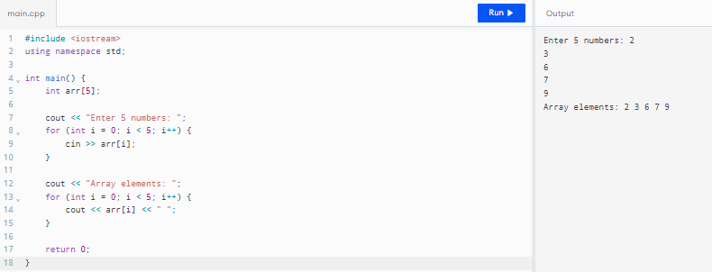

Task 2: Sum of Array Elements
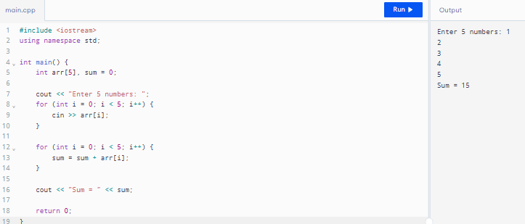

Task 3: Find Maximum and Minimum
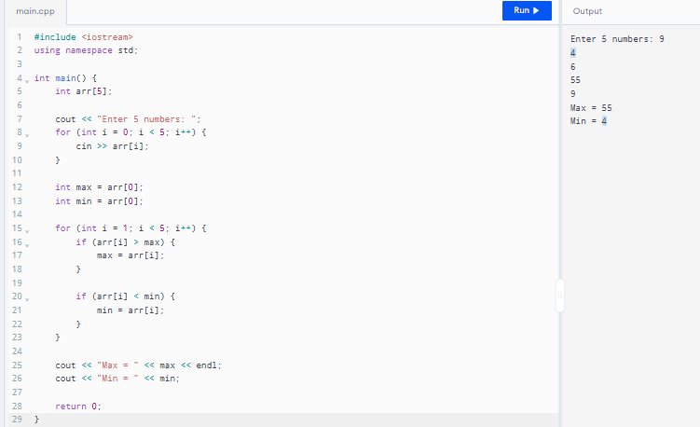

Task 4: Search an Element
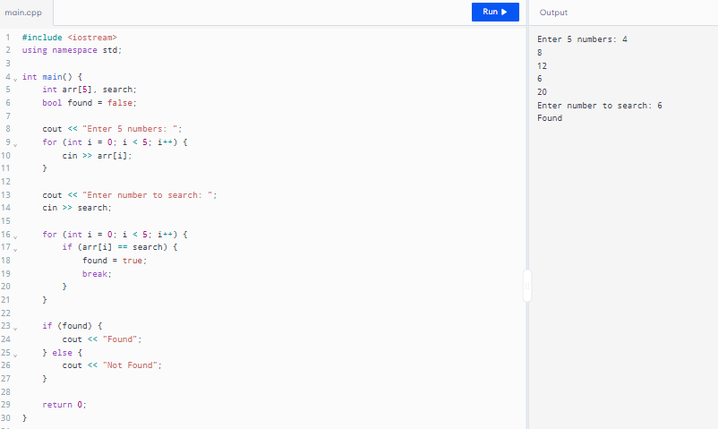

Task 5: Reverse the Array
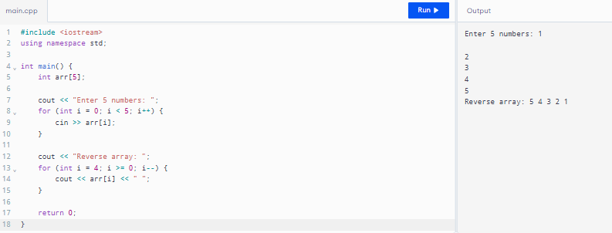

Task 6: Count Even and Odd Numbers
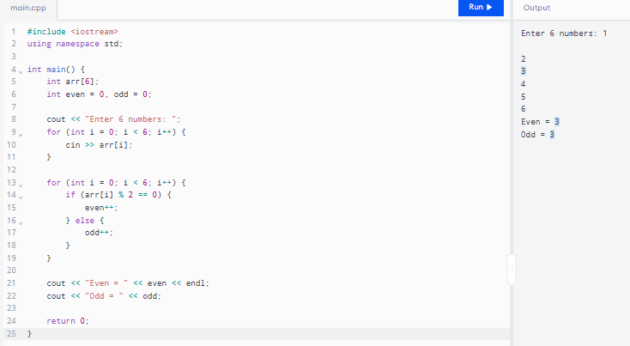

Task 7: Copy One Array to Another
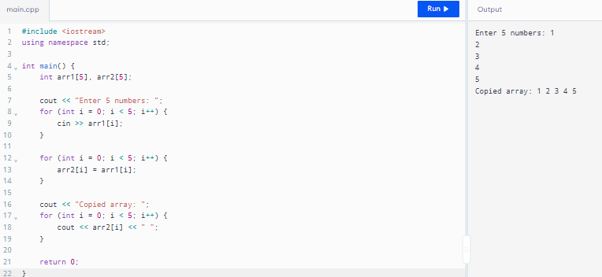

Task 8: Find the Second Largest Element
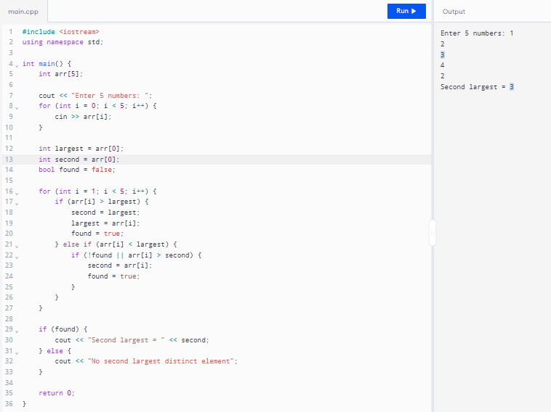

Task 9: Merge Two Arrays
